
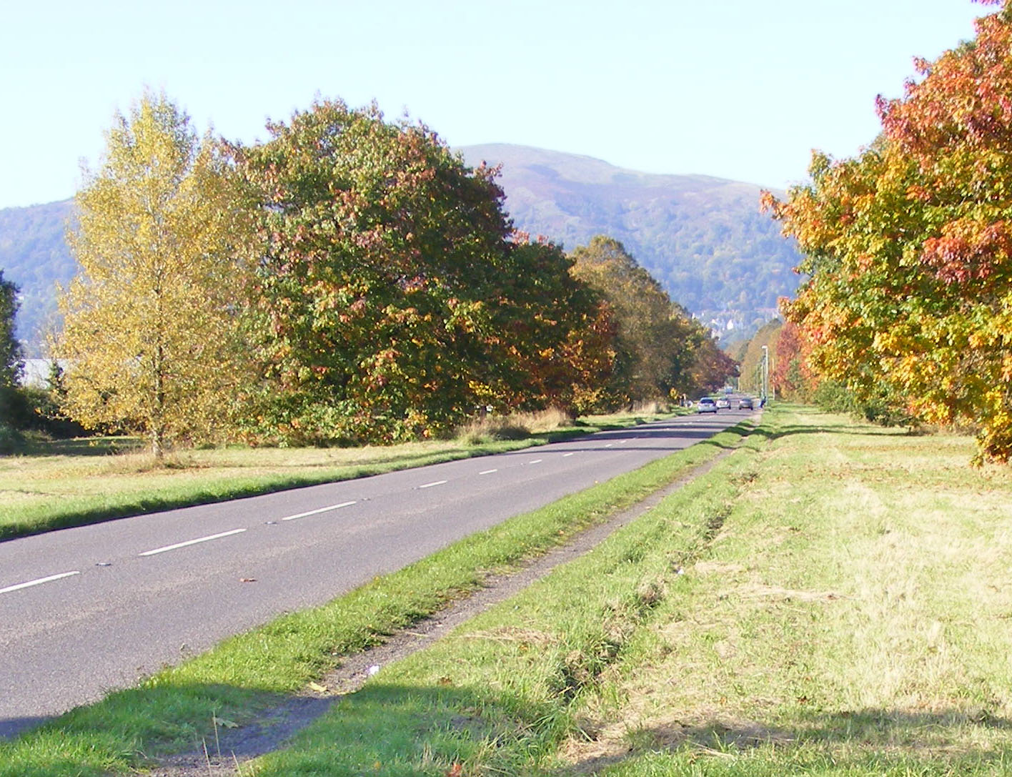
Friends of the Commons of Malvern Update
7th September 2018
Ref. Easements application
Thank you for your support.
Although it seems to have gone quiet, there has been a lot going on behind the scenes.
The key thrust of our arguments, have been, and continue to be on opposing the easement application. Without this permission, there can be no housing development on the field.
It has been difficult and frustrating, as the Trust (Conservators) continues to keep us in the dark, refusing to provide more than the most basic details of the easement application, such as the size of the proposed development. However, rest assured we have been pressing the Trust on a number of fronts to determine what exactly is proposed and how the Trust’s duty lies first and foremost, in preserving the Common land which the proposed easements would destroy.
Some former Conservators are outraged at the approach of the current Trust members
1. We are now on Facebook. You can find us on,
Friends of the Commons of Malvern

https://www.facebook.com/FriendsCommonsMalvern

Please share the page, ‘like’ it and follow it. Regular updates are posted on here.
A web-site is due to be launched shortly
2. We have been:
Writing letters to our MP and to the Trust
Contacting individual Trust members
Telephoning relevant individuals
Writing letters to the Malvern Gazette and Observer

BBC Radio Hereford and Worcester are closely monitoring the ongoing situation, following Interviews with Residents and the Trust CEO on 17th August 2018.

We welcome any ideas to strengthen our case for rejecting the easements.
Could you also join us in our letter writing campaign?

To contact FOCOM email:
focom.org@gmail.com

More information is available at:
http://www.the-malvern-hills.uk/other_residents_association.htm
and
http://www.guarlfordparish.uk/noticeboard_additional.htm

oOo

