Important Diary Date
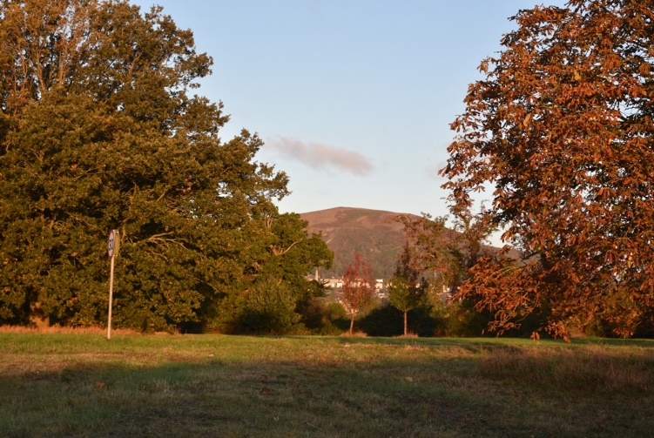
The Malvern Hills Trust has announced a
date of
Tuesday 19th March at 7pm Gryphon Room, Sports Complex, Malvern College,
Thirlstane Road
WR14 3PL
Chance Lane-Guarlford Road Easement meeting
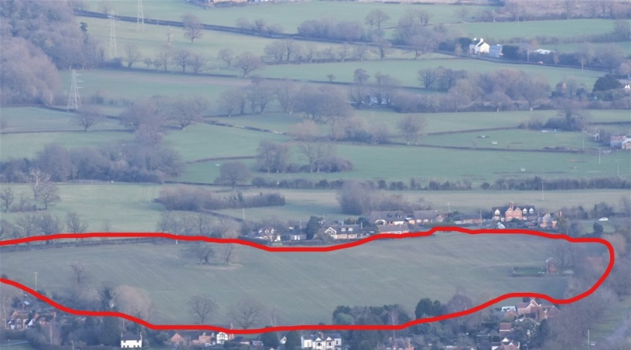
The relevant papers are on the MHT web-site
(Go to Home page, put in Chance Lane Easement into search facility, choose 2019.03.19 Special Board)

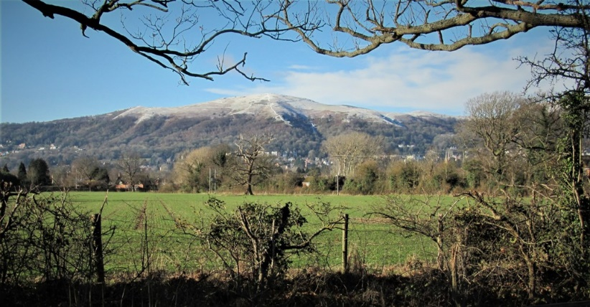
We are doing our best to argue the case against the Easement and we need your support on the night.
If this is passed, it will open the floodgates to total urbanisation of the area. The Common and its adjacent footpaths will become history.
If you are concerned about development on the Guarlford Straight, please come along.

